

PROJECT: MANAGEMENT SYSTEM

Date: 6 June 2024

Name: Muhammad Noor-ul-Hassan

Enrollment: 03-134222-071

Lab: Data Communication and Networking

Table of Contents

* Introduction
* Purpose

* VLAN

* DHCP
* DNS
* Components

Introduction:

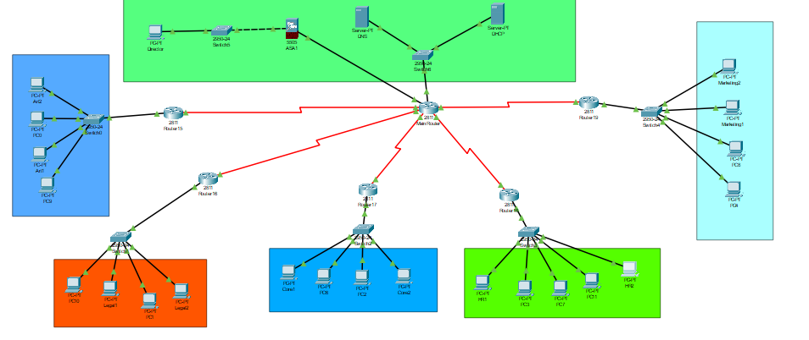

Office management system is built by networking. There are five branches and a head office for this management system. Servers, routers, and switches has been used to perform this management system. Office branches have PCs that are connected to switches, where the switches relate to routers.

There is a main router that relates to servers of Head office. The data sent from Head office will move to desire place of user. DHCP and DNS servers are used to perform this task

Firewall is also used to perform the security functions. If the head office server gets under cyber-attack then firewall will prevent those threats from unauthorized access.

The VLAN has used in between the switches to make a group within a network.

Purpose

The purpose of office management is to relates the new generation challenges that comes from transferring the data from one place to another. If there is a long range of connection, then this model will provide the server to send the data from shortest route to the receiver.

VLAN

VLAN stands for Virtual Local Area Networks. This technology allows to create separate isolated network segments with in a single physical network. Devices that are connected in same VLAN can communicate with each other.

It improves the security by segmenting the network into different VLANs, sensitive data can be isolated reducing the risk of unauthorized access.

VLANs make it easier to isolate and troubleshoot network issues by confining them to a specific segment of the network.

DHCP

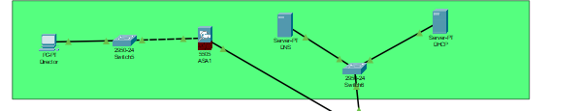

DHCP is a protocol that automatically assigns IP addresses and other network configuration parameters to devices (clients) on a network, allowing them to communicate efficiently. It eliminates the need for manual configuration of IP addresses, subnet masks, gateways, and DNS servers.

Key Components of DHCP

**DHCP Server:** The server that manages and assigns IP addresses and other network configuration settings.**DHCP Client:** The device that requests and receives an IP address and configuration from the DHCP server.**IP Address Pool:** A range of IP addresses that the DHCP server can assign to clients.**Lease Time:** The duration for which an IP address is assigned to a client. Once the lease expires, the client must renew the lease to continue using the IP address.

DNS

DNS (Domain Name System) is a hierarchical and decentralized naming system used to translate human-readable domain names (like www.example.com) into machine-readable IP addresses (like 192.0.2.1). This system is essential for the functioning of the internet, as it allows users to access websites and other resources using easy-to-remember names instead of numeric IP addresses.

COMPONENTS

* Switches

Switches are networking devices that operate at the data link layer (Layer 2) of the OSI model. They connect multiple devices within a local area network (LAN) and forward data packets between them based on the MAC (Media Access Control) addresses in the packets. Here's a detailed overview of switches:

* Router

Routers are crucial networking devices that operate at the network layer (Layer 3) of the OSI model. They are responsible for forwarding data packets between different networks, facilitating communication between devices across multiple networks, and directing traffic along the most efficient paths. Here's an in-depth overview of routers:Copper-straight Through

A copper straight-through cable, also known simply as a "straight-through cable," is a type of Ethernet cable in which the wiring configuration at one end of the cable matches the wiring configuration at the other end. In other words, the pin assignments at both ends of the cable follow the same pattern.

**Serial DTE**

A Serial DTE interface is a type of serial communication interface that serves as the endpoint for data transmission and reception on a networking device. DTE devices, such as routers or switches, typically use these interfaces to establish serial connections with other devices, such as modems or other routers, for purposes such as WAN (Wide Area Network) connectivity.

**Copper Crossover cable**

A copper crossover cable, also known simply as a "crossover cable," is a type of Ethernet cable in which the wiring configuration at one end of the cable is deliberately crossed over compared to the wiring configuration at the other end. This crossing over of wires allows for direct communication between two similar devices, such as two computers or two switches, without requiring a switch or a hub to facilitate the connection.

**Outputs**

**DHCP**

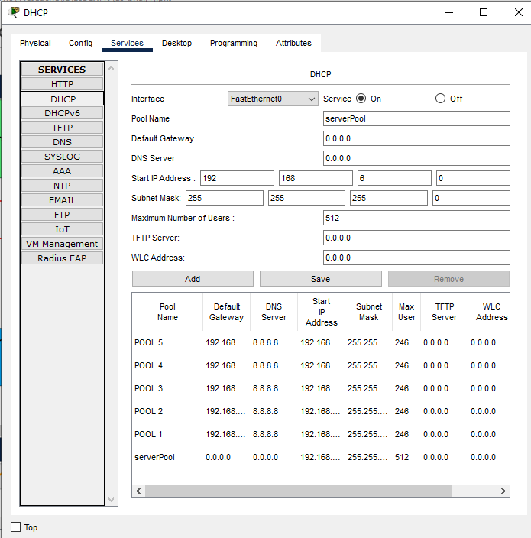

**Ping**

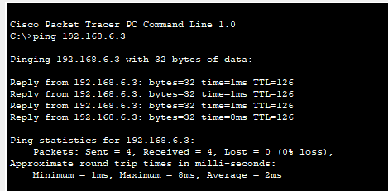

**VLAN**

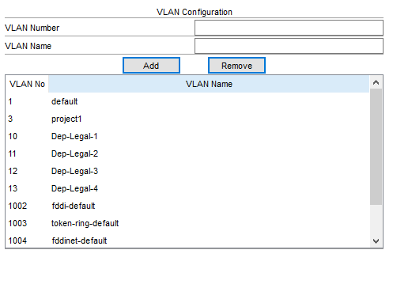



**OSPF**

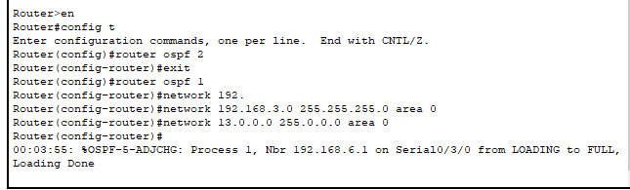

**References**

<https://youtu.be/Yj4ucY9FbWE?feature=shared>

<https://www.youtube.com/watch?v=JlsEViyqyKY>